# Stations of the Cross – Crieghton University

# (from the Church of England website)

# Introduction (in the Lady Chapel)

Priest: In the name of the Father, and of the Son, and of the Holy Spirit. **Amen**

Priest: Let us pray.

Almighty God, whose most dear Son went not up to joy but first he suffered pain, and entered not into glory before he was crucified: mercifully grant that we, walking in the way of the cross, may find it none other than the way of life and peace; through Jesus Christ our Lord, who is alive and reigns with you, in the unity of the Holy Spirit, one God, now and for ever. **Amen**

Let us walk with Christ, the path that leads to our salvation.

*As we approach the first station, we sing:*

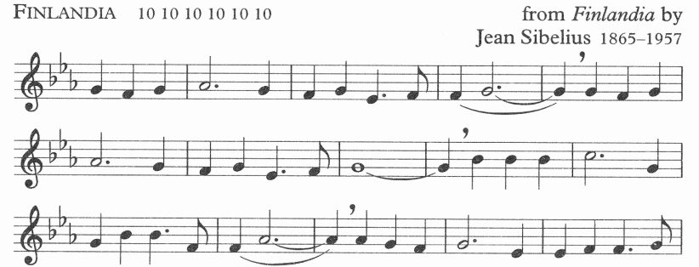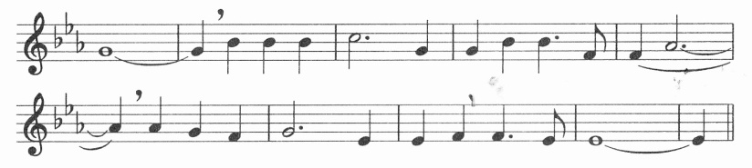

Be still, my soul: the Lord is at your side;

bear patiently the cross of grief and pain;

leave to your God to order and provide;

in every change he faithful will remain.

Be still, my soul: your best, your heavenly friend

through thorny ways leads to a joyful end.

# 1. Jesus Is Condemned to Die

Voice 2 Jesus stands in the most human of places.  He has already experienced profound solidarity with so many on this earth, by being beaten and tortured.  Now he is wrongfully condemned to punishment by death.  His commitment to entering our lives completely begins its final steps.  He has said "yes" to God and placed his life in God's hands.  We follow him in this final surrender, and contemplate with reverence each place along the way, as he is broken and given for us.

Voice 1 We adore you, O Christ, and we bless you.   
**All: Because by your holy cross you have redeemed the world.**

Voice 3: As I view the scene, I become moved by both outrage and gratitude.

I look at Jesus.  His face.  The crown of thorns.  The blood.  His clothes stuck to the wounds on his back.

Pilate washes his hands of the whole affair.  Jesus' hands are tied behind his back.

This is for me.  That I might be free.  That I might have eternal life.

As the journey begins I ask to be with Jesus.  To follow his journey. I express my love and thanks.

*As we approach the second station, we sing:*

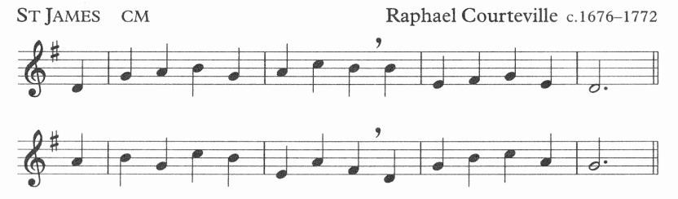

Thou art the Way: by thee alone

from sin and death we flee;

and they who would the Father seek

must seek him, Lord, by thee.

# 2. Jesus Carries His Cross

Voice 2 Jesus is made to carry the cross on which he will die.  It represents the weight of all our crosses.  What he must have felt as he first took it upon his shoulders!  With each step he enters more deeply into our human experience.  He walks in the path of human misery and suffering, and experiences its crushing weight.

Voice 1 We adore you, O Christ, and we bless you.   
**All: Because by your holy cross you have redeemed the world.**

Voice 3 I contemplate the wood of that cross.  I imagine how heavy it is.  I reflect upon all it means that Jesus is carrying it.

I look into his eyes.  It's all there.

This is for me.  So I place myself with him in this journey.  In its anguish.  In his freedom and surrender.  In the love that must fill his heart.

With sorrow and gratitude, I continue the journey.  Moved by the power of his love, I am drawn to him and express my love in the words that come to me.

*As we approach the next station, we sing:*

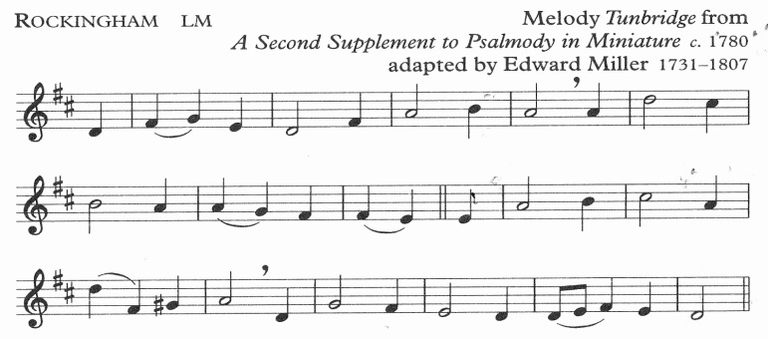

When I survey the wondrous cross

on which the prince of glory died,

my richest gain I count but loss,

and pour contempt on all my pride.

# 3. Jesus Falls the First Time

Voice 2 The weight is unbearable.  Jesus falls under it.  How could he enter our lives completely without surrendering to the crushing weight of the life of so many on this earth!  He lies on the ground and knows the experience of weakness beneath unfair burdens.  He feels the powerlessness of wondering if he will ever be able to continue.  He is pulled up and made to continue.

Voice 1 We adore you, O Christ, and we bless you.   
**All: Because by your holy cross you have redeemed the world.**

I stare at the weakness in his eyes.  I can look at his whole body and see the exhaustion.

As I behold him there on the ground, being roughly pulled up, I know forever how profoundly he understands my fatigue and my defeats.

This is for me.  In grief and gratitude I want to let him remain there.  As I watch him stand again and gain an inner strength, I accept his love and express my thanks.

*As we approach the next station, we sing [Rockingham p4]:*

Were the whole realm of nature mine,

that were a present far too small;

love so amazing, so divine,

demands my soul, my life, my all.

# 4. Jesus Meets His Mother

Voice 2 Jesus' path takes him to a powerful source of his strength to continue.  All his life, his mother had taught him the meaning of the words, "Behold, the handmaid of the Lord."  Now they look into each other's eyes.  How pierced-through her heart must be!  How pained he must be to see her tears!  Now, her grace-filled smile blesses his mission and stirs his heart to its depth.  Love and trust in God bind them together.

Voice 1 We adore you, O Christ, and we bless you.   
**All: Because by your holy cross you have redeemed the world.**

Voice 3 As I watch them in this place along the way, I contemplate the mystery of love's power to give strength.

She knows the sorrow in every mother's heart, who has lost a child to tragedy or violence.

I look at the two of them very carefully, and long for such love and such peace.

This is for me.  Such incredible freedom.  The availability of a servant.  I find the words to express what is in my heart.

*As we approach the next station, we sing:*

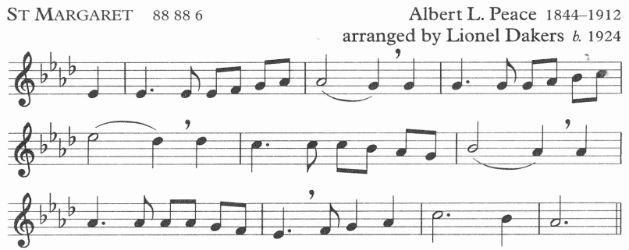

O love that wilt not let me go,

I rest my weary soul in Thee:

I give Thee back the life I owe,

That in Thine ocean depths its flow

May richer, fuller be.

# 5. Simon Helps Jesus Carry His Cross

Voice 2 Jesus even experiences our struggle to receive help.  He is made to experience the poverty of not being able to carry his burden alone.  He enters into the experience of all who must depend upon others to survive.  He is deprived of the satisfaction of carrying this burden on his own.

Voice 1 We adore you, O Christ, and we bless you.   
**All: Because by your holy cross you have redeemed the world.**

Voice 3 I look into his face and contemplate his struggle.  His weariness and fragility.  His impotence.

I see how he looks at Simon, with utmost humility and gratitude.

This is for me. So I feel anguish and gratitude.  I express my thanks that he can continue this journey.  That he has help.  That he knows my inability to carry my burden alone.

I say what is in my heart, with deep feeling.

*As we approach the next station, we sing:*

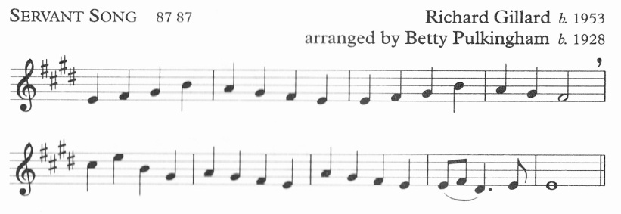

Brother, sister, let me serve you,

let me be as Christ to you,

pray that I may have the grace

to let you be my servant too.

# 6. Veronica Wipes the Face of Jesus

Voice 2 Jesus' journey is at times brutal.  He has entered into the terrible experiences of rejection and injustice.  He has been whipped and beaten. His face shows the signs of his solidarity with all who have ever suffered injustice and vile, abusive treatment.  He encounters a compassionate, loving disciple who wipes the vulgar spit and mocking blood from his face.  On her veil, she discovers the image of his face - his gift to her.  And, for us to contemplate forever.

Voice 1 We adore you, O Christ, and we bless you.   
**All: Because by your holy cross you have redeemed the world.**

Voice 3 What does the face of Jesus hold for me?  What do I see, as I look deeply into his face?

Can I try to comfort the agony and pain? Can I embrace him, with his face so covered with his passion?

The veil I behold is a true icon of his gift of himself. This is for me.  In wonder and awe, I behold his face now wiped clean, and see the depth of his suffering in solidarity with all flesh.

I say what I can say, to express my gratitude.

*As we approach the next station, we sing [Servant Song p8]:*

I will hold the Christ-light for you

in the night-time of your fear;

I will hold my hand out to you,

speak the peace you long to hear.

# 7. Jesus Falls the Second Time

Voice 2 Even with help, Jesus stumbles and falls to the ground.  In deep exhaustion he stares at the earth beneath him.  "Remember, you are dust and to dust you will return."  He has seen death before.  Now he can feel the profound weakness of disability and disease and aging itself, there on his knees, under the weight of his cross.

Voice 1 We adore you, O Christ, and we bless you.   
**All: Because by your holy cross you have redeemed the world.**

Voice 3 I contemplate Jesus brought very low.  As I behold him there on the ground, with all the agony taking its toll on him, I let my heart go out to him.

I store up this image in my heart, knowing that I will never feel alone in my suffering or in any diminishment, with this image of Jesus on the ground before me.

This is for me, so I express the feelings in my heart.

*As we approach the next station, we sing:*

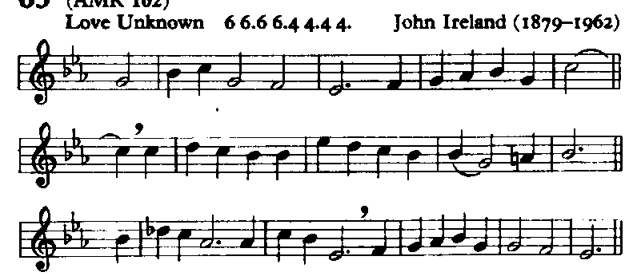

He came from his blest throne,

salvation to bestow;

but men made strange, and none

the longed-for Christ would know.

But O, my Friend indeed, my Friend indeed,

who at my need his life did spend!

# 8. Jesus Meets the Women of Jerusalem

Voice 2 The women of Jerusalem, and their children, come out to comfort and thank him.  They had seen his compassion and welcomed his words of healing and freedom.  He had broken all kinds of social and religious conventions to connect with them.  Now they are here to support him.  He feels their grief.  He suffers, knowing he can't remain to help them more in this life.  He knows the mystery of facing the separation of death.

Voice 1 We adore you, O Christ, and we bless you.   
**All: Because by your holy cross you have redeemed the world.**

Voice 3 I look at their faces.  So full of love and gratitude, loss and fear.  I contemplate what words might have passed between them.

I remember all his tender, compassionate, merciful love for me.  I place myself with these women and children to support him.

This is for me.  So, I let this scene stir up deep gratitude.

*As we approach the next station, we sing [Servant Song p8]:*

I will weep when you are weeping;

when you laugh, I’ll laugh with you.

I will share your joy and sorrow

till we’ve seen this journey through.

# 9. Jesus Falls the Third Time

Voice 2 This last fall is devastating.  Jesus can barely proceed to the end.  Summoning all this remaining strength, supported by his inner trust in God, Jesus collapses under the weight of the cross.  His executioners look at him as a broken man, pathetic yet paying a price he deserves.  They help him up so he can make it up the hill of crucifixion.

Voice 1 We adore you, O Christ, and we bless you.   
**All: Because by your holy cross you have redeemed the world.**

Voice 3 I pause to contemplate him there on the ground. The brokenness that makes me whole.  The surrender that gives me life.

I pause to experience and receive how completely he loves me. He is indeed completely poured out for me.

As I treasure this gifted experience, I express what is in my heart.

*As we approach the next station, we sing:*

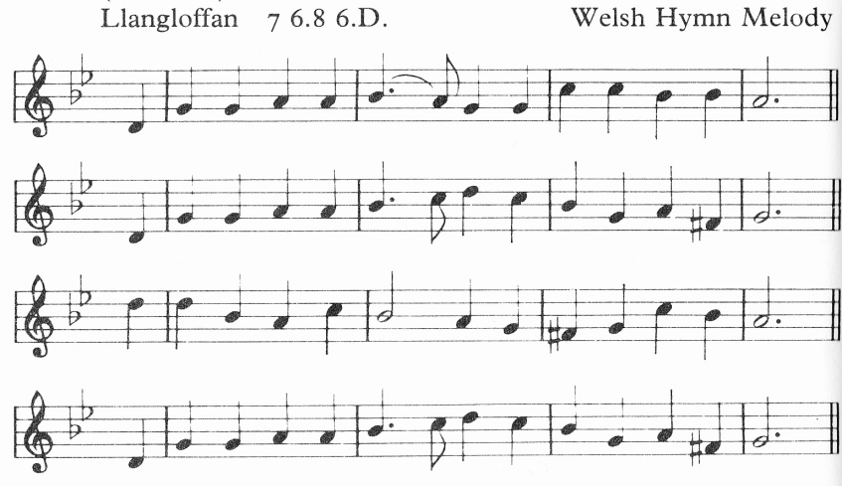

The groaning of creation,

wrung out by pain and care,

the anguish of a million hearts

that break in dumb despair;

O crucified Redeemer,

these are thy cries of pain;

O may they break our selfish hearts,

and love come in to reign.

# 10. Jesus Is Stripped

Voice 2 Part of the indignity is to be crucified naked. Jesus is completely stripped of any pride.  The wounds on his back are torn open again.  He experiences the ultimate vulnerability of the defenceless. No shield or security protects him.  As they stare at him, his eyes turn to heaven.

Voice 1 We adore you, O Christ, and we bless you.   
**All: Because by your holy cross you have redeemed the world.**

Voice 3 I pause to watch the stripping.  I contemplate all that is taken from him.  And, how he faces his death with such nakedness.

I reflect upon how much of himself he has revealed to me.  Holding nothing back.

As I look at him in his humility, I know that this is for me, and I share my feelings of gratitude.

*As we approach the next station, we sing [Llangloffan p12]:*

We hear the cry of anguish,

we see thy life outpoured,

where battlefield runs red with blood,

our brother’s blood, O Lord.

And in that bloodless battle,

the fight for daily bread,

where might is right and self is king,

we see thy thorn-crowned head.

# 11. Jesus Is Nailed to the Cross

Voice 2 Huge nails are hammered through his hands and feet to fix him on the cross.  He is bleeding much more seriously now.  As the cross is lifted up, the weight of his life hangs on those nails.  Every time he struggles to pull himself up to breathe, his ability to cling to life slips away.

Voice 1 We adore you, O Christ, and we bless you.   
**All: Because by your holy cross you have redeemed the world.**

Voice 3 I make myself watch the nails being driven through his flesh.  And I watch his face.

I contemplate the completeness of his entry into our lives.  Can there be any pain or agony he would not understand?

This is for me.  Nailed to a cross to forever proclaim liberty to captives.  What sorrow and gratitude fill my heart!

*As we approach the next station, we sing [Rockingham p4]:*

See from his head, his hands, his feet,

sorrow and love flow mingled down;

did e’er such love and sorrow meet,

or thorns compose so rich a crown!

# 12. Jesus Dies on the Cross

Voice 2 Between two criminals, a mocking title above his head, with only Mary and John and Mary Magdalene to support him, Jesus surrenders his last breath:  "Into your hands I commend my spirit."

Voice 1 We adore you, O Christ, and we bless you.   
**All: Because by your holy cross you have redeemed the world.**

Voice 3 I stand there, at the foot of the cross, side by side with all of humanity, and behold our salvation.

I carefully watch and listen to all that is said.

And then, I experience the one who gives life pass from life to death, for me.  I console Mary and John and Mary.  And let them console me.

This is the hour to express the deepest feelings within me.

*As we approach the next station, we sing [Llangloffan p12]:*

O crucified Redeemer,

whose life blood we have spilt,

to thee we raise our guilty hands,

and humbly own our guilt.

Today we see thy Passion

spread open to our gaze;

the crowded street, the country lane,

its Calvary displays.

# 13. Jesus Is Taken Down From the Cross

Voice 2 What tender mourning!  Jesus' lifeless body lies in his mother's arms.  He has truly died.  A profound sacrifice, complete.

Voice 1 We adore you, O Christ, and we bless you.   
**All: Because by your holy cross you have redeemed the world.**

Voice 3 I behold this scene at the foot of the cross.  I contemplate touching, caressing his body.  I remember all his hands have touched, all who have been blessed by his warm embrace.

I pause to let it soak in.  He knows the mystery of death.  He has fallen into God's hands.

For me.  That I might love as I have been loved.  I pour out my heart to the God of all mercies.

*As we approach the next station, we sing [St Margaret p7]:*

O Cross that liftest up my head,

I dare not ask to fly from Thee:

I lay in dust life's glory dead,

And from the ground there blossoms red

Life that shall endless be.

# 14. Jesus Is Laid in the Tomb

Voice 2 They take the body of Jesus to its resting place.  The huge stone over the tomb is the final sign of the permanence of death.  In this final act of surrender, who would have imagined this tomb would soon be empty or that Jesus would show himself alive to his disciples, or that they would recognize him in the breaking of bread?  Oh, that our hearts might burn within us, as we realize how he had to suffer and die so as to enter into his glory, for us.

Voice 1 We adore you, O Christ, and we bless you.   
**All: Because by your holy cross you have redeemed the world.**

Voice 3 I pause to contemplate this act of closure on his life.  In solidarity with all humanity, his body is taken to its grave.

I stand for a moment outside this tomb.  This final journey of his life has shown me the meaning of his gift of himself for me.  This tomb represents every tomb I stand before with fear, in defeat, struggling to believe it could ever be empty.

In the fullness of faith in the Risen One, given by his own Holy Spirit, I express my gratitude for this way of the cross.  I ask Jesus, whose hands, feet and side still bear the signs of this journey, to grant me the graces I need to take up my cross to be a servant of his own mission.

***[In the Eucharist, please turn to page 19]***

***During Lent,*** *the pilgrims return to the Lady Chapel, singing:*

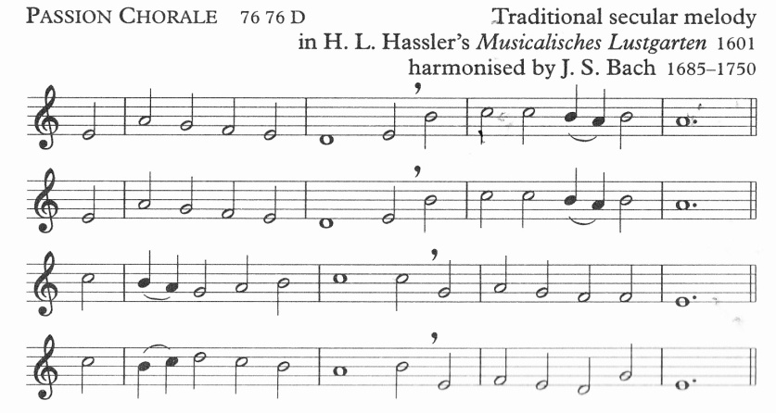

In this bitter passion,

good Shepherd, think of me

with thy most sweet compassion,

unworthy though I be:

beneath thy cross abiding

for ever would I rest,

in thy dear love confiding,

and with thy presence blest.

*In the Lady Chapel:*

And so the journey ends, where we began. Or does it? As we walked the Way of the Cross, was there one thought, one idea that caught your attention and, by following it, will help you take a step closer to our Lord? The truth is that we have all moved on; we are not the people who set out on this journey tonight. Transformed by the love of God, we now step back into our daily lives, filled with gratitude for all that Jesus has done for us, and renewed in service and discipleship.

Let us pray:

Almighty God, whose most dear Son went not up to joy but first he suffered pain, and entered not into glory before he was crucified: mercifully grant that we, walking in the way of the cross, may find it none other than the way of life and peace; through Jesus Christ our Lord, who is alive and reigns with you, in the unity of the Holy Spirit, one God, now and for ever. **Amen**

***If the Eucharist follows****, everyone returns to their seat. There is no blessing at this point. Otherwise****:***

Christ crucified draw you to himself, to find in him a sure ground for faith, a firm support for hope and the assurance of sins forgiven; and the blessing of God almighty, the Father, the Son and the Holy Spirit, be among you and remain with you always. **Amen**